Social Media Accounts:
Facebook
Instagram
TikTok
YouTube
LinkedIn
NextDoor - 2024 Neighborhood Favorite
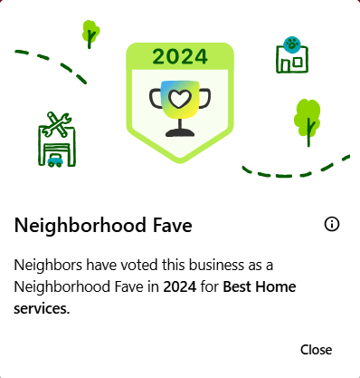
Google My Business - 167 Reviews - 5 Star Rating

Supporting Videos:
Client Testimonial from Our Grand Opening
Insurance Claim Client Testimonial
Metal Fabrication Services Client Testimonial (Spanish)
Spanish Social Media Post Example
Educational TikToks:
What to Expect When Getting a Roof Replacement
How We Make Our Metal Drip Edge
Flat Roofing
Metal Roofing

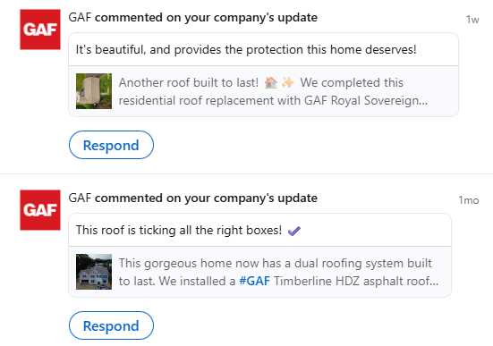
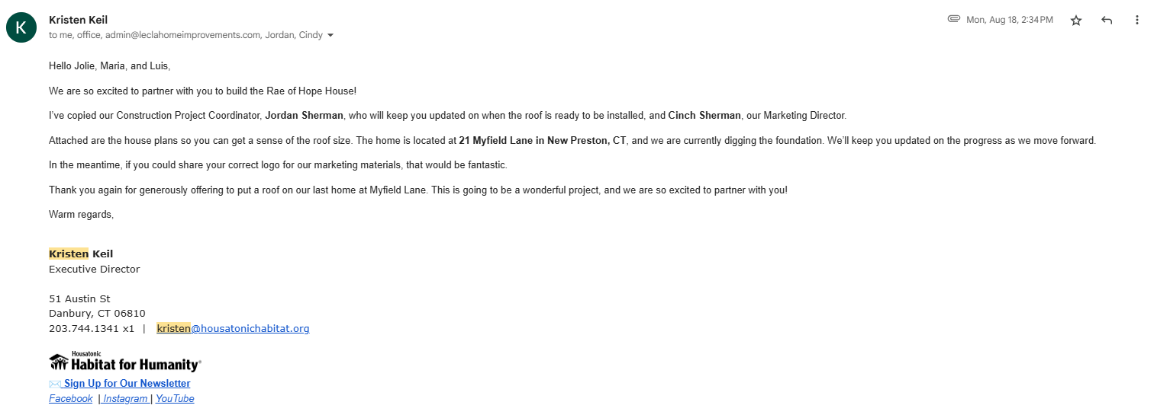
Comments from GAF on our LinkedIn Posts:
Upcoming Partnership with Habitat for Humanity where we will be donating a roof for a home that is handicap accessible:
Social Media Posts including estimate details for transparency: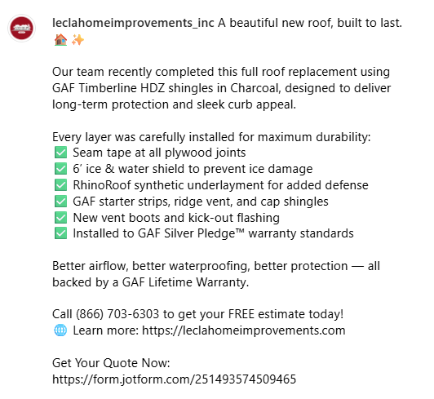
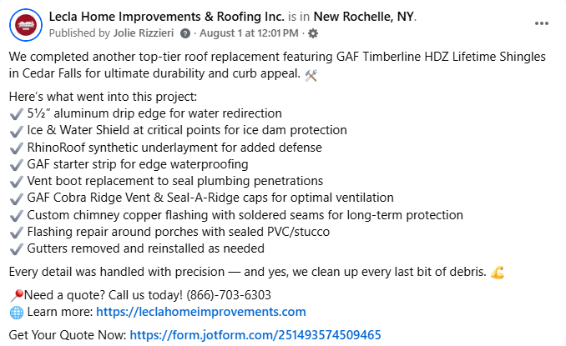

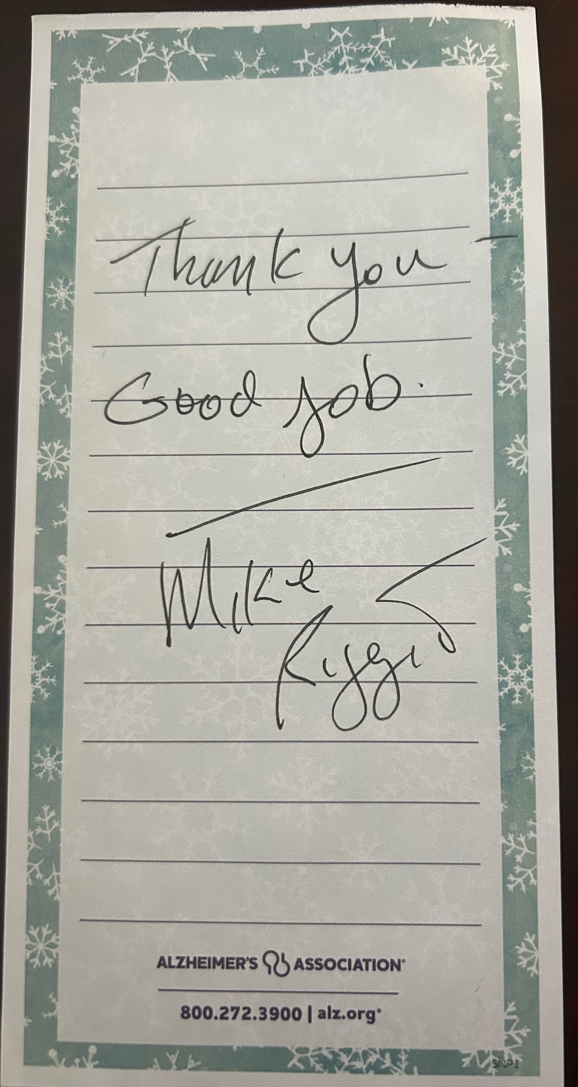
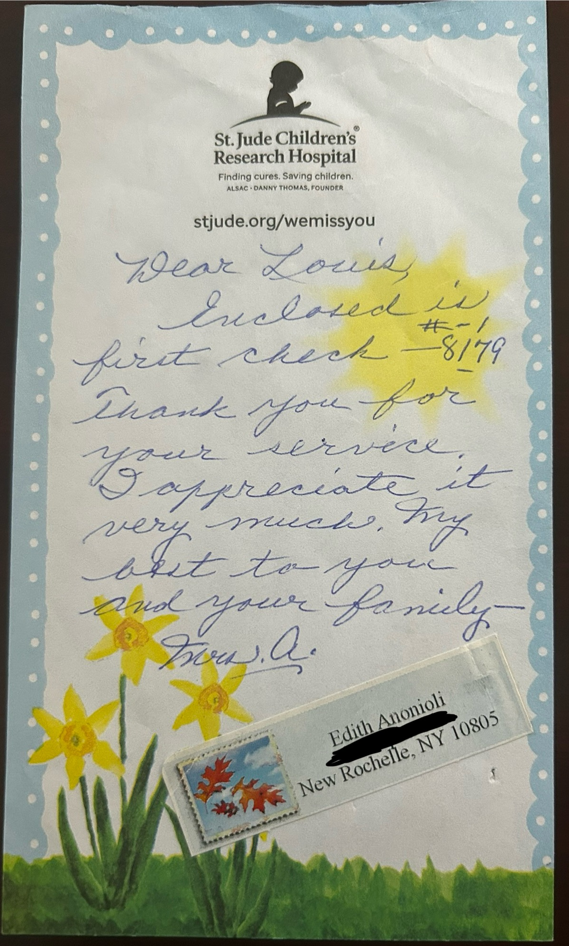
Thank you Letters from Customers:

